Allen Edwards Primary School

Approval Body: | Allen Edwards Primary School Governing Body
Approval Date: | September 2025
Implementation Date: | September 2025
Review Date: | September 2026
Behaviour Policy

ALLEN EDWARDS PRIMARY SCHOOL
Contents
Our Vision and Aims of the Policy 2
Aims and Objectives 3
What we Expect of Staff, Parents and Children 3
How Outstanding Behaviour is encouraged 4
Whole School Rewards System 4
Certificates and Trophies: 4
House Points: 4
Strategies for Promoting Positive Behaviour at Allen Edwards: 5
Consequences at Allen Edwards 5
Reasons for Suspension or Exclusion 8
Internal Suspension 8
Fixed Term External Suspension: 8
Permanent Exclusion: 9
Safeguarding 9
Playground Behaviour 9
Screening, Searching and Confiscation 10
Recording Incidents on CPOMS 11
Reporting incidents to parents and carers 12
Parent/ Carer Conduct 12
Appendix 1 – Behaviur Chart 16
Appendix 2 – Yellow Reflection 17
Appendix 3 – Amber Reflection 19
Appendix 4 – Red Reflection 21
Appendix 5 - Additional strategies for supporting positive behaviour with SEND Pupils: 23
Appendix 6 - Guide Lines for consequences at each stage 24

Behaviour Policy

Our Vision and Aims of the Policy
At Allen Edwards we aim to create a positive, safe and secure environment where everyone is treated with dignity and respect so that all members of the school community can excel and enjoy school life to the full. We encourage pupils to be responsible for their own behaviour and treat each other and all members of staff with respect at all times. We aim to build positive relationships with children and their families. We all believe that everyone in school is important and should be valued. We expect each individual to respect one another, their families, culture and beliefs.

Our children aspire to be good citizens and demonstrate a strong moral purpose through a values-led school ethos. Our school values honesty, respect, tolerance, kindness and trust, along with the United Nations Convention on the Rights of the Child (UNCRC) Articles are at the heart of all school planning, policies and vision as a Rights Respecting School.

Children take responsibility for their own behaviour, learning from mistakes whilst
developing a sense of moral purpose which supports them in making good decisions
throughout their lives.

The UNCRC articles which inform this policy are:

Article 2: Non-Discrimination – The Convention applies to every child without discrimination, whatever their ethnicity, sex, religion, language, abilities or any other status, whatever they think or say, whatever their family background.

Article 12: Respect the Views of the Child – Every child has the right to say what they think
in all matters affecting them, and to have their views taken seriously.

Article 15: Freedom of Association – Every child has the right to meet with other children
and young people and to join groups and organisations, as long as this does not stop others
from enjoying their rights.

Article 29: Goals of Education - Education must develop every child’s personality, talents
and abilities to the full. It must encourage the child’s respect for human rights, as well as
respect for their parents, their own and other cultures and the environment.

Article 31: Leisure, play and culture – Every child has the right to relax, play and join in a
wide range of cultural and artistic activities.

Article 34: Sexual exploitation - Governments must protect children from all forms of sexual abuse and exploitation.

Aims and Objectives
- Our behaviour policy across the whole school is rooted in ensuring the dignity of every child at all times and supporting them to better understand themselves so they can be successful as they move through school and beyond.
- To have a whole school approach to behaviour and its management, where all staff are united in their values and beliefs.
- To have a whole school behaviour policy that reflects the educational needs of our pupils and promotes equity for all.
- To cultivate a culture of ‘zero-tolerance’ whilst ensuring support is in place when incidents do occur to support all children.
- To ensure that everyone who enters the school feels respected and valued during the time that they spend here.
- To have a real emphasis on the promotion of positive behaviour so that we create a safe and healthy environment where our children feel valued, respected and cared for.
- To establish a clear and consistent set of high expectations that everyone knows and understands as acceptable or unacceptable behaviour.
- To encourage parents to share the responsibility of the school as a positive and responsible community.
- To ensure that equal opportunities are considered in all aspects of policy procedure.

What we Expect of Staff, Parents and Children
We want our school to be a place where:
- We value and respect each other.
- We care for others.
- We are honest and can be trusted.
- We are polite and considerate.
- There is a calm working environment in which thought and effort are put into work.
- Everyone is treated with dignity and respect.

School will then be a place where we can:
- Learn to work together.
- Enjoy achievements.
- Find new friends.
- Feel safe and share ideas and problems.

To promote outstanding behaviour, adults will:
- Match work to pupils’ abilities.
- Treat people and property with respect.
- Think carefully about what they say and how it makes other people feel.
- Celebrate positive learning and attitudes with Dojos and House Points.
- Respond to negative behaviour in a fair manner.

To promote outstanding behaviour, children will:
- Follow our ‘Behaviour for Learning’ guidelines, which include the school drivers and values.
- Work collaboratively with adults and pupils.
- Communicate their ideas, knowledge and feelings confidently.
- Be resourceful, using ideas, equipment and actions to support and enhance their learning.
- Working with, and for, all members of the school community.
- Striving to work to the best of their ability to recognise and achieve possibilities.
- Be rewarded for positive ‘Behaviour for Learning’ through the giving of Class Dojo points.

How Outstanding Behaviour is encouraged:
We aim to create a culture of respect with every member of our school community. We believe that good behaviour is promoted through the organisation of the classroom and school, so that everyone understands what is expected of them. When problems arise, they are dealt with in a consistent and fair manner, whilst respecting different needs and backgrounds.

Whole School Rewards System
Reward systems are a consistent and continuous process across school by all members of staff who work with our children. Our endeavour is that the most important reward that our children can receive is intrinsic: that our children will be challenged by our rich and inclusive curriculum so that they can strive to be the best they can be. We support this with our extrinsic reward system to build all of our children’s self-esteem and create a positive climate for learning.

Certificates and Trophies:
- Class Star of the Week certificate for achieving an aspect of the school drivers (Collaboration, Community, Communication, Resourcefulness and Possibilities) or the school values (respect, honesty, kindness, trust and respect). Parents are invited to this assembly to see their child receive their certificate.
- Class Attendance Certificate and Trophy – a class from each of KS1 and KS2 who have the highest percentage attendance over the week.
- Children with 100% attendance over a full term will receive a certificate and a badge. Bronze for the first term, Silver for the second term and Gold for the third term.
- Head teacher Awards given for showing an extremely high level of motivation and positive attitude towards learning and the school community. This will include homework and achievements outside of school.
- P.E. Certificate, which are awarded to two children each week for positive attitude and achievements during P.E. lessons.
- Times table/ Number Bonds award

House Points:
Allen Edwards has a system of house points for all pupils. Every child is placed in a house (siblings are placed together).

The house system is there to promote collaboration and support amongst peers and continue to promote community.

There are 4 houses: Red, Blue, Green and Yellow. Children are given Dojos for showing adults and their peers kindness, collaboration, communication, community, honesty and resourcefulness. For every 10 Dojos, the children will receive one house point. Each week these points will be counted and a winning team will be announced in assembly. Then each term, the team that has earned the most house points will take part in a celebration afternoon. Each house will have a house captain from year 6 and a vice captain from year 5 that will have responsibility for their houses.

Parents can follow their child on Class Dojo to see their achievements.

Strategies for Promoting Positive Behaviour at Allen Edwards:
- We are a Rights Respecting School so our children learn about their rights and how to promote and protect them.
- Ensuring children’s understanding of positive behaviours through the use of the Green (positive) and Red (dysregualted/ negative) Choices used across school with visual represenations to support all children to access.
- Ensuring that as a school we celebrate diversity and support our children to learn about each other to foster an environment of respect.
- A trauma informed approach is used across school to support children to successfully access the classroom.
- Staff are supported to pause and consider the underlying reasons behind behaviour. We actively promote a culture of curiosity, where adults “stop and think about the why” rather than reacting to the behaviour itself. While there may not always be an obvious or immediate trigger, behaviour is never without reason. It may represent an accumulation of factors such as sensory overload, anxiety, changes in routine, communication difficulties, social misunderstandings, fatigue, hunger, illness or emotional distress.
- Staff have significant training and resoures to support children with additional needs to support their regulation and behaviours.
- Support is offered to pupils at risk of displaying negative behaviours to ensure they have the correct support the child to not repeat these.
- Lots of praise and encouragement so positive behaviour in constantly reinforced.
- Dojos, stickers and stamps to promote positive behaviour.
- An organised learning environment where everything is clearly labelled and there are great resources for every lesson which will enable our children to be independent and responsible learners.
- Visual displays of certificates, house point winners and fantastic learning in all class rooms to promote the positives of all children.
- Special jobs or responsibilities.
- Use of Class Dojo – Dojo points will be awarded throughout the day for specific behaviours related to the school’s drivers and values.
- Sharing our learning with children across school, other teachers, members of SLT and parents and carers.

Consequences at Allen Edwards
Consequences for red choices in behaviour and learning are intended to be clear and consistent. Each classroom has a display for the whole school behaviour management system base around Green (positive) and Red (dysregualted/ negative) Choices. This is a system developed to ensure that every child can access it regardless of their individual needs.

Below are outlines of the steps followed by all staff. Staff are, however, aware that they must also use their knowledge and understanding of the child when considering consequences as we must respond to the individual child to ensure an inclusive response.

For EYFS, year one and our children with special educational needs (where appropriate):

- If children make repeated red choices or a serious red choice, they are given time to reflect with regulation resources.
- Adults then support children to reflect using the booklet. Staff take children through a series of steps which encourage children to reflect on their behaviour and feelings in order to develop children’s self-awareness and model self-regulation strategies.
- Adults also model and suggest alternative actions and ways to build and repair relationships. A restoriative activity or conversation supports children to develop an understanding of red and green choices.
Below are examples of a reflection book that is used to helpall learners to express what has happened, why it has happened and how to repair what has happened, these will be available within every classroom to support any learners that require prompting (there are 7 stages to this booklet and these are just examples).
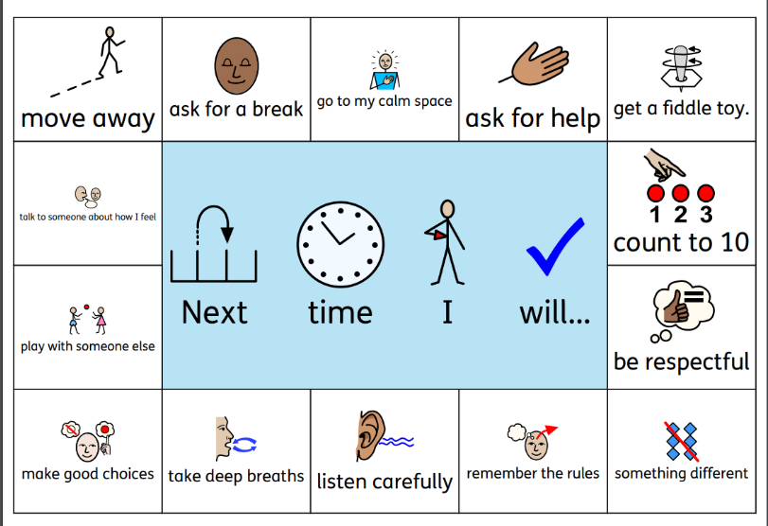
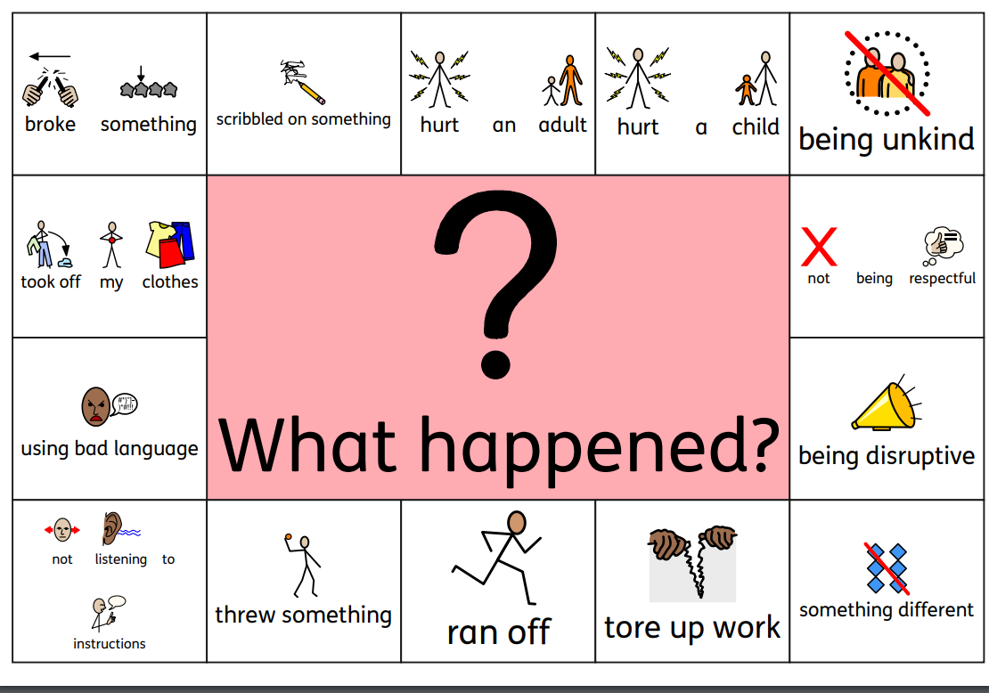

From year 2 – 6:

- Verbal warnings are clear and specify the behaviour that is disrupting learning. Children will be directed to the Red and Green Choices and asked, “Have you made a red or green choice?” This will allow the child to recognise that their choice of behaviour needs amending. *see appendix 4.
- A Yellow Reflection: If the behaviour continues, the child will complete a yellow reflection at the reflection table in their classroom for 10 minutes (see appendix 3).
- An Amber Reflection: If the child has returned to their learning and the behaviour continues, a time out in their partner class is given. They will complete an amber reflection and return to class after 10 minutes (see appendix 4).
- A Red Reflection: If after each of the previous steps has been completed and the child’s behaviour continues to be unacceptable, they will be asked to complete a red reflection. A red reflection will mean that the child will need to be brought to the SLT office. The children must bring their yellow and red reflections so these can be discussed with the child (see appendix 5). For instances of child on child abuse, children will complete a red reflection with a member of SLT immediately.

We use a system of reflections so all children are able to communicate their views on an incident and use this time to calm down after an incident. If a child is unable to write their reflection, they may be asked to draw or given a scribe.

*see appendix 5 for types of behaviour that might be seen at each stage.

All Red Reflections must be recorded on CPOMS, our school communication system. Class teacher will then need to arrange to meet parents to explain the incident and consequences given.

- Children can, in extreme circumstances, advance straight to a Red Reflection. At this point, a member of SLT must be involved (extreme behaviour includes fighting, swearing, serious defiance or disrespect to adults). There will be a meeting with a parent to discuss this behaviour.
- When a child has more than 3 Red Reflections in a half term then a meeting will be arranged with a parent or carer with a member of SLT and the class teacher to discuss their child’s behaviour and how we can provide more support to that child.
- If behaviour continues, a report card or further adaptations will be put in place to prevent further escalation and ensure a positive outcome. For a child on a report card (mainstream only), targets will be created at a meeting with a member of senior leadership (SLT), the class teacher, parents and the child and will be monitored every day by SLT. Consequence steps will be agreed in a report card meeting with parents, cares and SLT.

Possible consequences for red choices in school could be:

- Reflection and restorative conversations.
- Restorative justice e.g. litter picking or helping around school where the incident relates to school property being mistreated.
- Time out at break times and lunch times to complete learning or reflect on red choices. Timings are at the discretion of the teacher. The children will be given a comfort break to go to the toilet and have water.
- Removal of priveledges e.g. pitch time missed or timeout out from playtime activities.
- Time out from class.
- Internal suspension.
- Fixed term external suspension.
- Referrals to the PRU.
- Permanent exclusions.
*No exclusion will be permitted unless all other avenues have been exhausted.

After all incidents, we ensure that restoration has been carried out between those involved, this may be a conversation after the incident, a session to repair relationships or several sessions with a learning mentor, staff, therapists or member of SLT.

Reasons for Suspension or Exclusion
- Serious breach of the school’s rules or policies.
- Risk of harm to the education or welfare of the child or others in the school.

Once other strategies/ consequences have been used or in the event of more serious incidents (see below), the school may be left with no alternative but to suspend or exclude a student. Exclusions may take the form of internal or external exclusion.

Internal Suspension
Internal suspension is a planned strategy in response to an incident, where a child has:
- Demonstrated significant defiance towards an adult.
- Reached Stage 4 of the Behaviour Policy ladder.
- Been verbally or physically aggressive towards adults of pupils.
- Continually disrupted the learning of others.
- Child on child abuse: physical, sexual or prejudiced or discriminatory e.g. racism, homophobia, sexism.

The aim is to avoid a formal exclusion with the intention that the consequences of violent behaviour and disruption are managed confidently and consistently within the school setting.

Internal susoensions remove a pupil from their usual timetabled lessons and place them apart from their peers. Work will be set for pupils, which may not always be the same as their peers within the lesson. Parents will be informed of the consequence and a letter will be sent.

All suspensions are considered based on the individual student and the school’s holiostic understanding of that pupil.

Fixed Term External Suspension:
A fixed term exclusion is put into place for serious breaches of the school rules and behaviour policy. In such cases, the Headteacher or Deputy Headteacher will investigate the incident thoroughly and consider all evidence to support the allegation, taking into account of the school’s policies and the individual child. Parents will be informed as soon as possible and the decision will be confirmed in writing. Work will be provided for the child to do at home.

All students returning from a fixed term suspension are required to attend a reintegration meeting, accompanied by a parent. This meeting will seek to establish practical ways in which further exclusion can be avoided and behaviour modified to acceptable standards in partnership between the student, parent and school. The headteacher or deputy headteacher has the authority to exclude in these instances.

All suspensions are considered based on the individual student and the school’s holiostic understanding of that pupil.

Permanent Exclusion:
A permanent exclusion is a very serious decision and the Headteacher will consult with the Deputy Headteacher and the Governing Body before enforcing it.
A permanent exclusion can be used after at least two temporary suspensions have failed to have an effect. However, in certain circumstances, the Headteacher may decide to impose a permanent exclusion for a serious one-off incident.
As with temporary suspension, it will follow a range of strategies and be seen as a last resort or it will be in response to a very serious breach of school rules and policies such as:

- Serious threats or violence against another pupil or a member of staff.
- Serious damage to school property impacting the learning of others.
- Persistent bullying.
- Persistent racial harassment.
- Possession or use of an illegal drug on school premises.
- Instances of child on child abuse that are ongoing or serious.
- Continuously disruptive and dangerous behaviour that prevents others from learning.

Parents will be invited in for a meeting to discuss this and next steps will be planned out including a Tier 2 placement referral to Lambeth. Parents will also be informed immediately in writing. Parents will also be informed of their right to appeal.

Please see Exclusion Policy for further information.

All suspensions are considered based on the individual student and the school’s holiostic understanding of that pupil.

Safeguarding
An exclusion will not be enforced if doing so may put the safety of the child at risk. In cases where parents will not comply by, for example, refusing to collect the child, the child’s welfare is the priority. In this situation, depending on the reason for exclusion, the school may consider an internal exclusion until the end of the day, implementing the original exclusion decision from the time the child is collected from school or, in more severe circumstances, the school may contact Social Services and/or the police to safely take the pupil off site.

Investigation
If there is an incident in school, this will be investigated thoroughly by the senior leadership team and all children involved will be given an opportunity to give their account. Children may be placed separately in another classroom or in one of the senior leadership team’s offices whilst an investigation is carried out. No blame will be placed on any of the children until the incident has been fully investigated. If the incident happens at the end of the day, school may decide to inform parents that the incident will be investigated the following day.

Playground Behaviour
To provide continuity from the classroom for the children, we continue to use a yellow, amber and red reflection system in the playground.

The playground is set up into zones where there are different activities taking place.

There are activity rules in the playground to support children’s understanding of how to play effectively. All adults promote oracy within the playground to help children communicate with each other when they are unhappy with something that has happened. There are Playground Mediators in the playground, who will be nominated by their class teachers, to support with activities in the playground.

If our playground rules are not being followed by a child, then sanctions will be given in the playground. Children are treated with dignity at Allen Edwards at all times.

Step One: Children will be asked if they have made a red or a green choice. This will act as a warning and reminder to the child of the appropriate choices.
Step Two: If the behaviour continues, the child will be asked to leave the activity and play at another activity.
Step Three: If behaviour continues, children a member of SLT will be called for to remove the child from the playground where they will complete a red reflection.

There are circumstances in the playground where children will be asked to go straight to a member of SLT. See appendix 7.

Behaviour Off School Site including Online
When wearing school uniform or if the pupil is identifiable as being an Allen Edwards pupil, incidents that occur off-site may be managed in line with our behaviour policy this includes incidences on electronic devices. These may include verbal harassment and sharing of inappropriate images. If children’s online behaviour is not inkeeping with the school’s behaviour policy, the school may choose to manage this in line with our behaviour policy.

Incidents on social media and Whatsapp, where the conduct of pupils is inapproproate and impacts other students or adults, will be dealt with in line with our behaviour policy.

Mallicieous Allegations Against Members of Staff
If an allegation is made by a pupil against a member of staff and is proved to be unfounded or malicious, the LADO may decide to refer the child to Children and Families’ Services for assessment as a child in need. Malicious allegations made by pupils may also be dealt with under our behaviour policies if this is more appropriate. Malicious allegations may warrant an exclusion depending on the severity.

Screening, Searching and Confiscation
It is the responsibility of the pupils who have mobile phones to hand them in to the school office before the bell goes for the beginning of the school day. Once a mobile phone has been confiscated, the parent/carer must collect it from the office.

Certain items are prohibited from site.

List of banned items:

- Gaming equipment
- Jewellery or personal adornments that do not fit with the uniform code e.g. bracelets, chains, earrings that are not studs
- Football or any kind of trading cards
- Sweets and gum
- Knives or weapons
- Alcohol
- Illegal drugs
- Stolen items
- Tobacco, cigarette papers, e-cigarettes and vapes
- Fireworks
- Pornographic images
- Any article that a member of staff reasonably suspects has been, or is likely to be, used to commit an offence or injure a person or damage property

School have a duty to report illegal items such as knives and pornographic images to the police. Under common law, school have the right to search pupils for any items if the pupil agrees. If staff have reasonable grounds for suspecting that the pupil is in possession of a prohibited item a search can be made.
With the pupil or parent’s consent, school may search electronic devices. If staff have good reason to suspect that there is something on the device that data or a file on the device could cause harm, undermine the safe environment of the school and disrupt teaching or be used to commit an offence, they can search the device without consent.
If data is found that is likely to consistute a criminal offence, it must be handed to the police.
Where there are images or data on the phone, school staff can online delete them if the parent or child refuse to do it themselves.

Recording Incidents on CPOMS
- This should be logged under the main student involved. In an incident where other children are involved, their names can be linked to the report. Then the appropriate category will need to be marked, for example, racism, defiance etc.
- Where the incident took place.
- Where applicable, the reason why force was needed to ensure the safety of the child, peers or staff.
- How the incident started and developed including details of the pupil’s behaviour, what was said by each of the parties, the steps taken to diffuse the situation.
- The pupil’s response and outcome of the situation.
- Details of any injuries suffered by the pupil, other pupils, a member of staff or property.
- For all incidences of prudice behaviour, SLT will review the incident and log the level of incidence to support us to reduce all incidents of prujidce related behavuiour in school and provide appropriate support for children.
- No offence was intended or taken.
- Hurt or distress was caused, but the offending behaviour is unlikely to be repeated.
- Hurt or distress was caused and the pupil(s) responsible had previously been warned and had input explaining that their behaviour was unacceptable.
- Substantial hurt or distress was caused, and/or the behaviour was based on substantial hostility and prejudice, and/or the behaviour may be repeated.

Reporting incidents to parents and carers
Staff at the school will apply the behaviour policy appropriately and as they see fit based on their knowledge of the pupils and the individual context.
- Where incidents are deemed, by the school, to be a serious behaviour incident (see the behaviour ladder from stage 4), parents will be informed.
- In some cases, where necessary, low level behaviour incidents will be reported to parents and carers. It is at the schools discretion that these incidents are reported.

Parent/ Carer Conduct
We expect our staff to be treated with respect by all parents and carers of the children.
We expect parents and carers to show respect and concern for everyone in our community by:

- Setting a good example in their own speech and behaviour towards all members of the School community
- Working together with teachers for the benefit of all children: this includes approaching the school to discuss and resolve any issues of concern in an appropriate manner
- Appropriately reprimanding their own children for inappropriate behaviour which could otherwise lead to conflict, aggression or upset
- Respecting the School environment and property.
- Parents do not have the right to discuss other pupils with staff or other parents
- Parents should not speak about other pupils in a way that could be considered derogatory
- Parents do not have the right to ask staff about the behaviour of other pupils or be part of any conflict resolutions between pupils, for example asking for other pupils to apologise to their own child. This is the role of staff
- Parents do not have the right to tell staff how to manage behaviour within the context of the school setting.

Our staff cannot tolerate parents, carers or visitors:

- Displaying disruptive, abusive or aggressive behaviour, including using loud and/or offensive language or displaying temper
- Approaching someone else’s child in order to discuss, chastise them or physically punish them
- Wilfully damaging or destroying school property
- Sending emails, Dojos, making phone calls or posting social media messages that are disrespectful, abusive or threatening
- Smoking, consuming alcohol or misusing any substance on school property or accessing the School site whilst intoxicated.
- Inappropriate conduct on the school premises (including but not limited to the examples listed above) will be reported to the appropriate authorities. If there is any concern that inappropriate behaviour is compromising the safety or well-being of any child this will be reported to our Headteacher who may decide to seek advice and support from Early Help or Children’s Social Care.

Potential next steps for unacceptable conduct
We are proud that our school is open and welcoming to all who would like to support our children. We also expect our parents and other adults to help the school community in a variety of ways. However, our overriding priority is providing a safe learning environment for our children and a safe working environment for our staff.
The school expects its staff to behave professionally in these situations and attempt to diffuse the situation where possible, seeking the involvement as appropriate of other colleagues. However, all staff have the right to work without fear of violence and abuse.
The Headteacher and Governors have the right to ban an offending adult from entering the school’s grounds or contacting specific members of staff in order to safeguard our school community.
Each situation will be considered individually and leaders will seek to ensure that the visitor involved has the opportunity to present their side of events. A ban can be for a limited period of time and reviewed or it can be permanent. This is a decision taken at the Headteacher’s discretion and is based on the details of an incident being drawn together to inform as fair a decision as possible. Wherever possible, a warning will be given to a parent/carer who might be demonstrating inappropriate behaviour. If a ban is issued this would typically be for a time limited period and then subject to review. However if aggression or intimidation continue, or where there have been serious acts of aggression, a parent, carer or other adult may be banned permanently by the Headteacher.

The following steps will be taken when a site ban has been decided upon:
- The adult will be warned, in writing, that s/he is banned from the premises, subject to review by a specified date. The suggested duration of a site ban is one half term.
- They will be advised that they have a right to appeal the ban by writing to the Chair of Governors within 10 school days setting out the reason(s) for appeal.
- Where an assault has led to a ban, a statement indicating that the matter has been reported to the police will be included.
- Where appropriate, arrangements for pupils being delivered to and collected from the School gate will be clarified.
- The Chair of Governors will be informed of the ban.
- The School will keep a log of relevant incidents as evidence.
- The ban will be reviewed at the end of the relevant period and may be extended if the school has grounds for continued concern regarding the relevant adult’s conduct.
- The relevant adult will be informed of the outcome of the review and advised whether the site ban is to be lifted or extended. There will be a right of appeal against a decision to extend the site ban, which can be exercised by writing to the Chair of Governors within 15 school days setting out the reason(s) for appeal. It is an offence under section 547 of the Education Act 1996 for any person (including parents/carers) to cause a nuisance or disturbance on school premises. The police may be called to assist the school in removing a parent but local authorities and governing bodies may also authorise the removal of a person if they have reasonable cause to believe that the person is causing a nuisance or disturbance.
Conclusion Pupils learn best when there is a positive partnership between home and School, and whilst every effort is made to work with parents and carers this will only be possible within a context of mutual respect.
Related Policies:

- Positive Physical Handling
- Exclusion Policy
- Safeguarding and Child Protection Policy
- SEND Policy
- Staff Code of Conduct
- Whistle-Blowing Policy
- Low-Level Staff Concerns Policy

Appendix 1 – Behaviur Chart

Name of child:
Class: Date W/C:
Targets
1.
2.
3.
On report to: ___________________________________
 | Session 1 |  |  | Session 2 |  |  | Break |  |  | Session 3 |  |  | Session 4 |  |  | Assembly |  |  | Lunch |  |  | Session 5 |  |  | End of Day |  |  | On report to:
Mon
Tues
Weds
Thurs
Fri

Aim: % /135
Consequences:
- If …………gets 2 crosses in a session, he will get a time out in Year 3 for the rest of the session.
- If ……………………. gets 2 time outs in one day, he will get an internal exclusion for the rest of the day. If this happens in the afternoon, he will get an internal exclusion for half of the next day.

If ……………………. does not co-operate fully with an internal exclusion, he will have to repeat it the following day.

Appendix 2 – Yellow Reflection

Yellow Reflection
Name:
Class:
Date:

What happened?
What red choices were made?
What would you do differently next time?
Apology to the person that was affected by the incident.

Yellow Reflection

Name:
Class:
Date:

What happened?
Draw a picture
Explain what happened to an adult and they will write brief notes here.

Appendix 3 – Amber Reflection

Amber Reflection
Name:
Class:
Date:

Why have you been asked to reflect in your partner class?
What red choices have you made?

What would you do differently next time?
Apology to the person that was affected by the incident.

Amber Reflection
Name:
Class:
Date:

What happened?
Draw a picture
Explain what happened to an adult and they will write brief notes here.

Appendix 4 – Red Reflection

Red Reflection
Name:
Class:
Date:

What has happened for you to be sent to a member of the Senior Leadership team?
What red choices did you make?
What will you do differently next time?
Apology to the person that was affected by the incident.

Red Reflection
Name:
Class:
Date:

What happened?
Draw a picture
Explain what happened to an adult and they will write brief notes here.

Appendix 5 - Additional strategies for supporting positive behaviour with SEND Pupils:

- Movement breaks
- Sensory circuit acccess
- Working away from the whole-class setting with an adult
- A job or task to distract or provide a break
- Fidgets
- Sensory room
- Indiviudal timetables
- Calm voice and demeanour
- Time to process, explain
- Looking for patterns, triggers
- Use of rewards chart
- Use of first and next
- Use of visuals to support understanding
- An adapted classroom environment
- Regulation boxes
- Following individual support plans
- Following individual Positive Handling plans
- Zones of Regulation
- Brain stem calming activities
- Further adult support
- Mentoring
- Therapy

Appendix 6 - Guide Lines for consequences at each stage

Stage | Behaviour | Examples of Possible Actions based on a school stuffs understanding of the individual child.
1 | Low level disruption, which includes:  - Calling out  - Wandering around the classroom  - Silly noises and tapping  - Not following instructions  - Talking | Positive reinforcement of expected behaviour.  Reference to red and green choices.  Verbal warning.  Parents are not contacted.  N0 record required on CPOMS.
2 | Low level disruption is continuous or higher level disruption, which includes:  - Refusal to work  - Unacceptable output  - Deliberate disruption  - Minor damage to property  - Repeatedly annoying other pupils | Child moved to avoid interactions with other children.  Reflections may be given at this point (5-10 minutes) at break or lunch by the classteacher  Moved to the reflection table to complete a yellow reflection for up to 10 minutes  Moved to complete work in a different part of the classroom where possible  Parents may be informed at the end of the day when they collect their child or in a phone call by teacher.  Yellow reflection is to be completed.  N0 record required on CPOMS.
3 | Persistent disruption and adverse behaviour that is affecting the learning of others, which includes:  - Deliberately throwing objects with the intention of harming or breaking  - Deliberate damage to property  - Harmful/offensive name calling  - Swearing  - Deliberate rudeness or defiance of adults | If a child’s behaviour continues to be unacceptable, an amber reflection will be given. An amber reflection will mean that the child will need a time out from the session in the partner class for up to 10 minutes.  Children may miss break or lunchtime with the classteacher  Parents are informed in a meeting at the end of the day or via a phone call (this must take place in the classroom and be more formal than a comment in the line).  Log required on CPOMS.
4 | Serious disruption to learning, which includes:  - Intentional,malicious physical harm to other children  - Fighting  - Malciious throwing of large dangerous objects  - Verbal abuse/swearing at a child or adult  - Vandalism  - Prejuidce incident e.g. Racist incidents, Homophobic, mysognistic  - Bullying  - Sexual harrassment | Pupil is sent to SLT  Prejudice related incident record form will be completed where appropriate  Record is put onto CPOMS  Red card reflection to be completed with SLT.  Restoration and repair  Parents are phoned/ meeting arranged or informed by letter with SLT and class teacher.  Internal Exclusion (a letter must be sent to parents for all internal exclusions).
5 | Significant disruptive behaviour, which includes:  - Extreme danger or violence  - Very serious challenge to authority  - Running out of school  - Malicious physical abuse to staff | Pupil is sent to SLT  Recorded on CPOMS  Restoration and repair  Parents are requested immediately into school for a meeting. Child does not return to class that day.  Fixed term External Exclusion with reintegration when the pupil returns.
6. | Child on Child Abuse:  - Bullying including cyberbullying, prejudice-based and discriminatory bullying  - Physical abuse including hitting, kicking, shaking, biting, hair pulling or otherwise causing harm purposefully  - Sexual violence  - Sexual harassment such as sexual comments, remarks, jokes and online sexual harassment | Pupil is sent to SLT  Recorded on CPOMS  Restoration and repair  Parents are requested immediately into school for a meeting. Child does not return to class that day.  Fixed term Internal or External Exclusion with reintegration when the pupil returns.
7. | Malicious allegations made against staff | This will have been investigated according to our Low-level concerns and whistleblowing procedures with the support of the LADO. If the allegations are deemed to be unfounded or malicious, we will liaise with the LADO regarding next steps. This ,ay include: a referral to social care, FTE or Permanent exclusion depending on the allegation.

